Speech Recognition using Hidden Markov Model

An implementation of the theory on a
DSK – ADSP-BF533 EZ-KIT LITE REV 1.5

Nick Bardici
Björn Skarin
____________________________________________________
Degree of Master of Science in Electrical Engineering
MEE-03-19
Supervisor: Mikael Nilsson
School of Engineering
Department of Telecommunications and Signal Processing
Blekinge Institute of Technology
March, 2006
Abstract

This master degree project is how to implement a speech recognition system on a DSK – ADSP-BF533 EZ-KIT LITE REV 1.5 based on the theory of the Hidden Markov Model (HMM). The implementation is based on the theory in the master degree project Speech Recognition using Hidden Markov Model by Mikael Nilsson and Marcus Ejnarsson, MEE-01-27. The work accomplished in the project is by reference to the theory, implementing a MFCC, Mel Frequency Cepstrum Coefficient function, a training function, which creates Hidden Markov Models of specific utterances and a testing function, testing utterances on the models created by the training-function. These functions where first created in MatLab. Then the test-function where implemented on the DSK. An evaluation of the implementation is performed.

Sammanfattning

Detta examensarbete går ut på att implementera en röstigenkänningssystem på en DSK – ADSP-BF533 EZ-KIT LITE REV 1.5 baserad på teorin om HMM, Hidden Markov Model. Implementeringen är baserad på teorin i examensarbetet Speech Recognition using Hidden Markov Model av Mikael Nilsson och Marcus Ejnarsson, MEE-01-27. Det som gjorts i arbetet är att utifrån teorin implementerat en MFCC, Mel Frequency Cepstrum Coefficient funktion, en träningsfunktion som skapar Hidden Markov Modeller av unika uttalanden av ord och en testfunktion som testar ett uttalat ord mot de olika modellerna som skapades av träningsfunktionen. Dessa funktioner skapades först i MatLab. Sedan implementerades testprogrammet på DSP:n Texas Instruments TMDS320x6711. Sedan utvärderades realtidstillämpningen.
Contents
1. Abstract 2

2. Contents 3

3. Introduction 6

4. Speech signal to Feature Vectors, Mel Frequency Cepstrum Coefficients 7

4.1 Speech Signal 9
4.1.1 Speech signal 9
4.2 Preprocessing 10
4.2.1 Preemphasis 10
4.2.2 VAD 12
4.3 Frameblocking and Windowing 14
4.3.1 Frameblocking 14
4.3.2 Windowing 15
4.4 Feature Extraction 18
4.4.1 FFT 18
4.4.2 Mel spectrum coefficients with filterbank 20
4.4.3 DCT - Mel-Cepstrum coefficients 22
4.4.4 Liftering 23
4.4.5 Energy Measure 24
4.5 Delta and Acceleration Coefficients 25
4.5.1 Delta coefficients 25
4.5.2 Acceleration coefficients 26
4.5.3 2-nd order polynomial approximation 27
4.6 POSTPROCESSING 28
4.6.1 Normalize 28
4.7 RESULT 29
4.7.1 Feature vectors 29

5. Hidden Markov Model 30

5.1 Introduction 30

6. HMM – The training of a Hidden Markov Model 31

6.1 Mean and variance 33
6.1.1 Signal – The utterance 33
6.1.2 MFCC 33
6.1.3 Mean 34
6.1.4 Variance 34
6.2 Initialization 35
6.2.1 A, state transition probability matrix 35
6.2.2 π, initial state probability vector 35
6.3 Multiple utterance iteration 35
6.3.1 B, output distribution matrix 35
6.3.2 α, The Forward variable 38

6.3.3 β, Backward Algorithm 40
6.3.4 c, scaled, the scaling factor, α scaled, β scaled 41
6.3.5 Log(P(O|λ)), LogLikelihood 45
6.4 Reestimation 46
6.4.1 A_reest, reestimated state transition probability matrix 47
6.4.2 µ_reest, reestimated mean 48
6.4.3 Σ_reest, variance matrix 48
6.4.4 Check threshold value 48
6.5 The result – the model 49
6.5.1 The Model 49

7. HMM–The testing of a word against a model – The determination problem 50

7.1 SPEECH SIGNAL 52
7.1.1 Speech signal 52
7.2 PREPROCESSING 52
7.2.1 MFCC 52
7.3 INITIALIZATION 52
7.3.1 Log(A), state transition probability matrix of the model 52
7.3.2 µ, mean matrix from model 52
7.3.3 Σ, variance matrix from model 52
7.3.2 Log(π), initial state probability vector 52
7.4 PROBABILITY EVALUATION 53
7.4.1 Log(B) 53
7.4.2 δ, delta 53
7.4.3 ψ, psi 53
7.4.4 Log(P*) 53
7.4.5 qT 53
7.4.6 Path 53
7.4.7 Alternative Viterbi Algorithm 54
7.5 RESULT 55
7.5.1 Score 55
8.The BF533 DSP

8.1 THE BF533 EZ-KIT LITE 58
8.2 SPEECH SIGNAL 59
8.2.1 The talkthrough modification 59
8.2.2 Interrupts 59
8.2.2 DMA, Direct Memory Access 59
8.2.2 Filtering 59
8.3 PREPROCESSING 60
8.3.1 Preemphasis 60
8.3.2 Voice Activation Detection 61
8.4 FRAMEBLOCKING & WINDOWING 62
8.4.1 Frameblocking 62
8.4.2 Windowing using Hamming window 63
8.5 FEATURE EXTRACTION 64
8.6 FEATURE VECTORS – Mel Frequency Cepstrum Coefficients 64
8.7 TESTING 65
8.8 INITIALIZATION OF THE MODEL TO BE USED 66
8.8.1 Log(A), state transition probability matrix of the model 66
8.8.2 µ, mean matrix from model 66
8.8.3 Σ, variance matrix from model 66
8.8.4 Log(π), initial state probability vector 66
8.9 PROBABILITY EVALUATION 66
8.9.1 Log(B) 66
8.9.2 δ, delta 66
8.9.3 ψ, psi 66
8.9.4 Log(P*) 66
8.9.5 qT 66
8.9.6 Path 67
8.9.7 Alternative Viterbi Algorithm 67
8.10 DELTA & ACCELERATION COEFFICIENTS 68
8.11 THE RESULT 68
8.11.1 The Score 68

9. Evaluation 69

9.1 MatLab 69
9.1.1 MatLab Result 69
9.2 DSK 75
9.2.1 DSK Result 75
10. Conclusions 77

10.1 Conclusion 77

10.2 Further work 77

11. References 78

3. Introduction

In our minds the aim of interaction between a machine and a human is to use the most natural way of expressing ourselves, through our speech. A speech recognizer, implemented on a machine as an isolated word recognizer was done through this project. The project also included an implementation on a DSK board due to the portability of this device.

First the feature extraction from the speech signal is done by a parameterization of the wave formed signal into relevant feature vectors. This parametric form is then used by the recognition system both in training the models and testing the same.

The technique used in the implementation the speech recognition system was the statistical one, Hidden Markov model, HMM. This technique is the best when working with speech processing [Rab]. This stochastic signal model is trying to characterize only the statistical properties of the signal. In the HMM design there is a need for solving the three fundamental problems, the evaluation, determination and the adjustment.

4. Speech signal to Feature Vectors, Mel Frequency Cepstrum Coefficients

When creating an isolated word speech recognition system you need to adjust the information which will be analyzed. The information in a analogue speech signal is only useful in speech recognition using HMM when it is in a discrete parametric shape. That is why the conversion from the analogue speech signal to the parametric Mel Frequency Cepstrum Coefficients is performed. The steps and each of its significances are presented in this chapter and an overview of these is presented in the figure below. See Figure 4.1

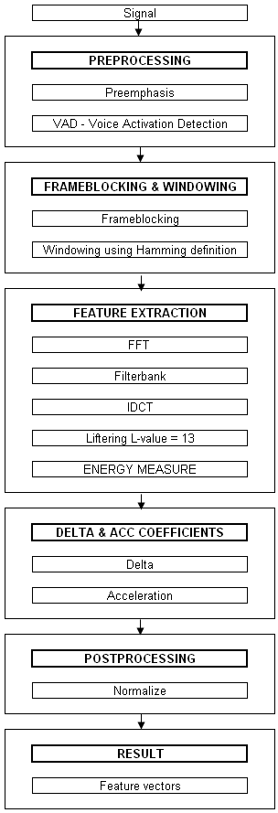
Figure 4.1

4.1 SPEECH SIGNAL

4.1.1 Speech signal
The original analogue signal which to be used by the system in both training and testing is converted from analogue to discrete, x(n) both by using the program CoolEdit©, http://www.cooledit.com and by using the DSK – ADSP-BF533 EZ-KIT LITE REV 1.5, http://www.blackfin.org. The sample rate, Fs used was 16kHz. An example of a signal in waveform sampled is given in Figure 4.2. The signals used in the following chapters are denoted with an x and an extension _fft e.g. x_fft(n) if an fft is applied to it. The original utterance signal is denoted x_utt(n), shown below.

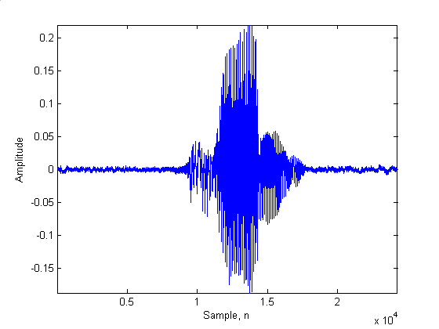
Figure 4.2 – Sampled signal, utterance of ‘fram’ in waveform

4.2 PREPROCESSING

4.2.1 Preemphasis
There is a need for spectrally flatten the signal. The preemphasizer, often represented by a first order high pass FIR filter is used to emphasize the higher frequency components. The composition of this filter in time domain is described in Eq. 4.1

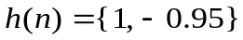 Eq. 4.1

The result of the filtering is given in Figure 4.3a and Figure 4.3.b

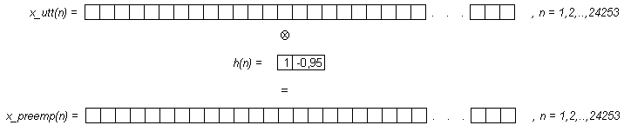
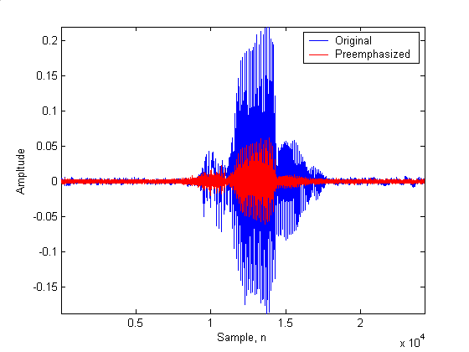
Figure 4.3a – Original signal(y(n)) and preemphasized(x(n))

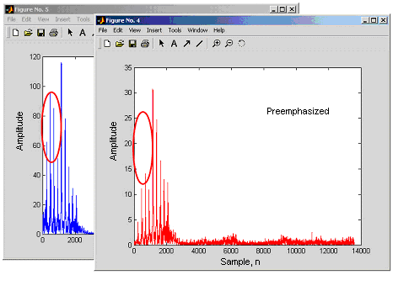
Figure 4.3b – Original signal(y(n)) and preemphasized(x(n))

In Figure 4.3b it shows how the lower frequency components are toned down in proportion to the higher ones.
4.2.2 VAD, Voice Activation Detection

When you have got access to a sampled discrete signal it is significant to reduce the data to contain only the samples which is represented with signal values, not noise. Therefore the need of a good Voice Activation Detection function is needed. There are many ways of doing this. The function used is described in Eq.4.2.

When beginning the calculation and estimation of the signal it is useful to do some assumptions. First we needed to divide the signal into blocks. The length of each block is needed to be 20ms according to the stationary properties of the signal [MM]. When using the Fs at 16 kHz, it will give us a block length of 320 ms. Consider the first 10 blocks to be background noise, then mean and variance could be calculated and used as a reference to the rest of the blocks to detect where a threshold is reached.

Eq. 4.2

The threshold in our case where tested and tuned to 1.2 * t_{w}. The result of the preemphasized signal cut down by the VAD is presented in Figure 4.4a and figure 4.4b.

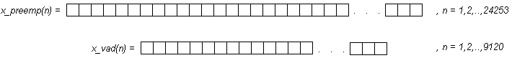
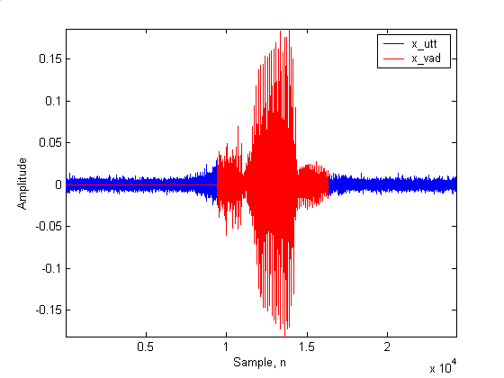
Figure 4.4a
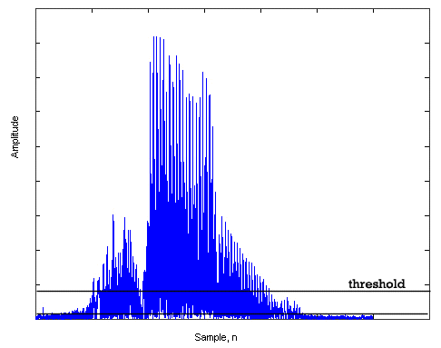

Figure 4.4b
4.3 FRAMEBLOCKING & WINDOWING

4.3.1 Frameblocking

The objective with framblocking is to divide the signal into a matrix form with an
appropriate time length for each frame. Due to the assumption that a signal within a frame of 20 ms is stationary and a sampling rate at 16000Hz will give the result of a frame of 320 samples.

In the framblocking event the use of an overlap of 62,5% will give a factor of separation of 120 samples.
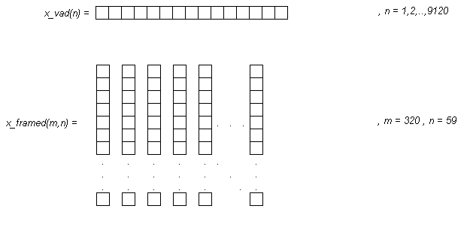
Figure 4.5

4.3.2 Windowing using Hamming window

After the frameblocking is done a Hamming window is applied to each frame. This window is to reduce the signal discontinuity at the ends of each block.

The equation which defines a Hamming window is the following:

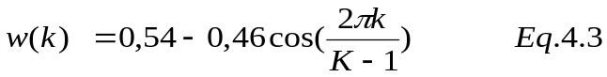

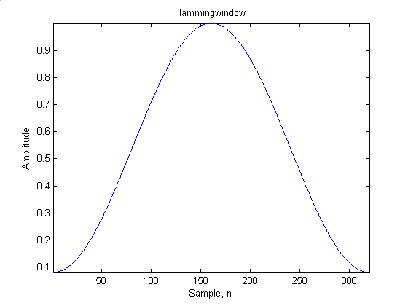
Figure 4.5
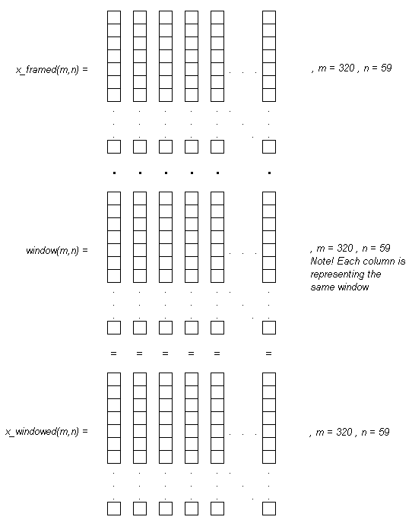

The Figure 4.6 shows the result of the frameblocking, block number 20.
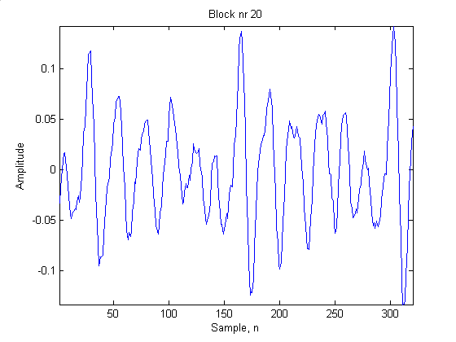
Figure 4.6

Figure 4.7 shows the block windowed by the window in Figure 4.7
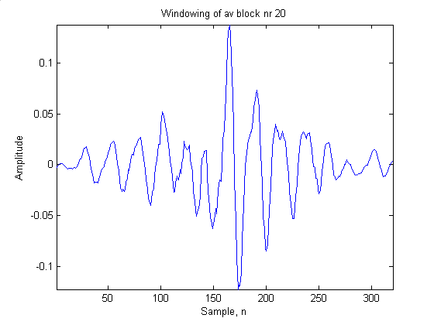
Figure 4.7
The result gives a reduction of the discontinuity at the ends of the block.

4.4 FEATURE EXTRACTION

The method used to extract relevant information from each frameblock is the mel-cepstrum method. The mel-cepstrum consists of two methods mel-scaling and cepstrum calculation.

4.4.1 FFT on each block

Use 512 point FFT on each windowed frame in the matrix. To adjust the length of the 20ms frame length, zero padding is used. The result for the block number 20 is given in Figure 4.8.

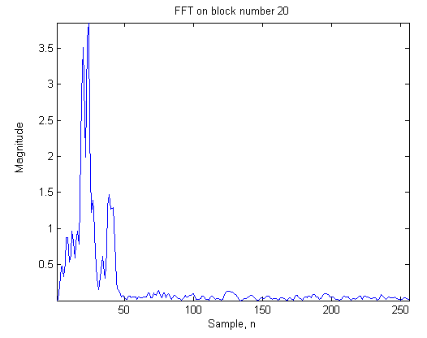
Figure 4.8
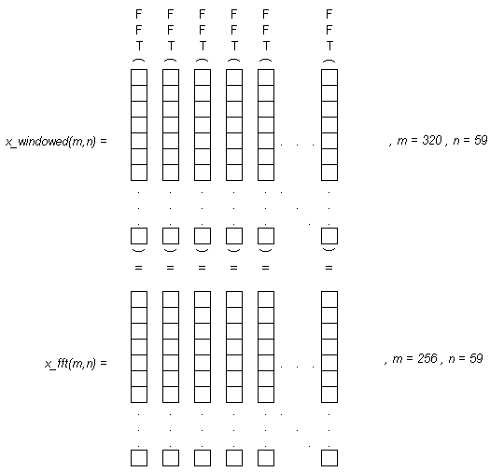

4.4.2 Mel spectrum coefficients with filterbank

The fact that the human perception of the frequency content in a speech signal is not linear there is a need for a mapping scale. There are different scales for this purpose. The scale used in this thesis is the Mel scale. This scale is warping a measured frequency of a pitch to a corresponding pitch measured on the Mel scale. The definition of the warping from frequency in Hz to frequency in Mel scale is described in Eq.4.4 and vice versa in Eq.4.5.

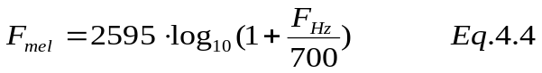
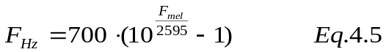

The practical warping is done by using a triangular Mel scale filterbank according to Figure 4.9 which handles the warping from Frequency in Hz to frequency in mel scale.

MELFILTERBANK[MM]
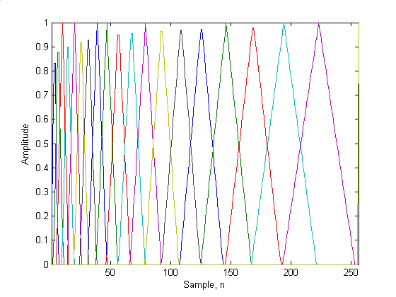
Figure 4.9

Theoretically it is done according to the following description. The summation is done to calculate the contribution of each filtertap. This will end up in a new matrix with the same number of columns as number of filtertaps. The first x_fft frame is multiplied with each of the filtertaps and in our case its 20 filtertaps. This will result in a 20 sample long vector. Then iterate the same procedure with every other frame and filtertaps.
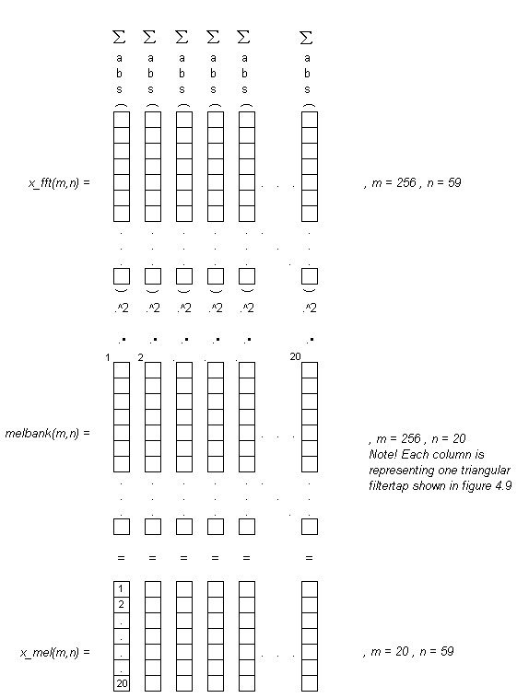

The element in x_mel(1,1) are obtained by summing the contribution from the first filtertap denoted 1 (MatLab notation. melbank(1:256,:)), then element x_mel(2,1) is obtained by summing the contribution from the second filtertap in melbank and so on.
4.4.3 Mel-Cepstrum coefficients, DCT – Discrete Cosine Transform

To derive the mel cepstrum of the warped mel frequency in the previous section the inverse discrete cosine transform will be calculated according to Eq.4.6. By doing the Discrete Cosine Transform the contribution of the pitch is removed [David].

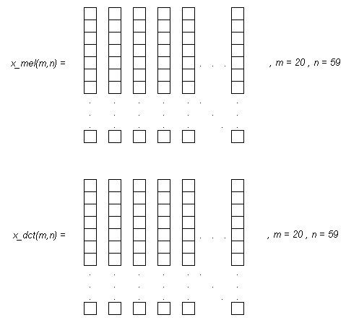

4.4.4 Liftering, the cepstral domain equivalent to filtering

When received the mel cepstrum coefficients there is a need for excluding some of them. The first two should be excluded due to an experiment by Nokia Research Centre [David]. The removed part is more likely to vary between different utterances of the same word, and a low-time lifter is therefore used. Then cut of the rest of the coefficients at the end of the vector when the wanted number is collected. An assumption of the number of coefficients needed is 13, thus we exchange the first coefficient with the energy coefficient, see section 4.4.5. There are two different lifters, L1 and L2, defined in Eq.4.7 and Eq.4.8. We use L1 in our implementation.

.
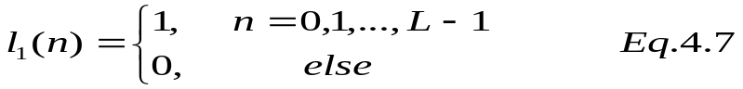

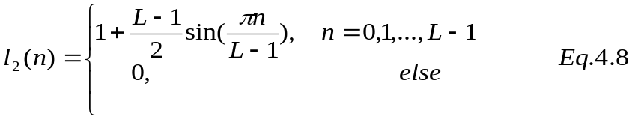

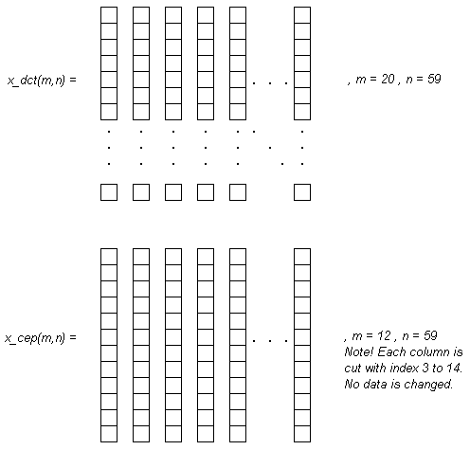
4.4.5 Energy Measure

To add an extra coefficient containing information about the signal the log of signal energy is added to each feature vector. It is the coefficient that were exchanged mentioned in the previous section. The log of signal energy is defined by Eq.4.9.

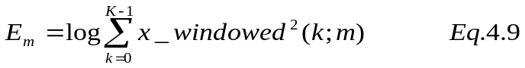

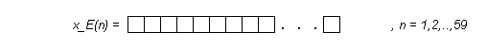

4.5 DELTA & ACCELERATION COEFFICIENTS

The delta and acceleration coefficients are calculated to increase the information of the human perception. The delta coefficients are about time difference, the acceleration coefficients are about the second time derivative.

4.5.1 Delta coefficients
The delta coefficients are calculated according to Eq.4.10.

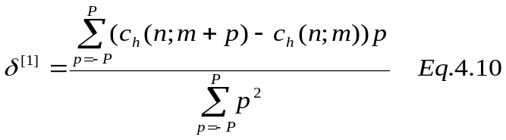

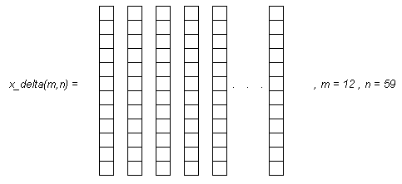

4.5.2 Acceleration coefficients

The acceleration coefficients are calculated according to Eq.4.11.
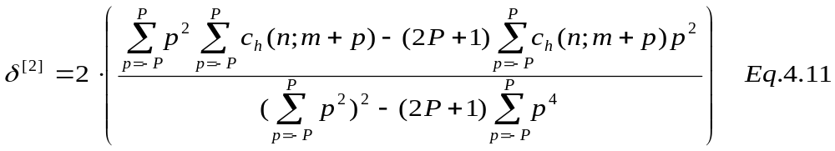

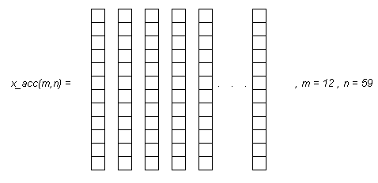
4.5.3 2-nd order polynomial approximation

Using the 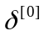(Eq.3.12),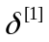 and 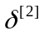the approximation of the mel-cepstrum trajectories could be approximated according to Eq.4.13. The Figure 4.10 is the result of using the fitting width P = 3.

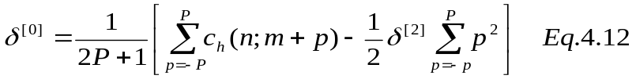

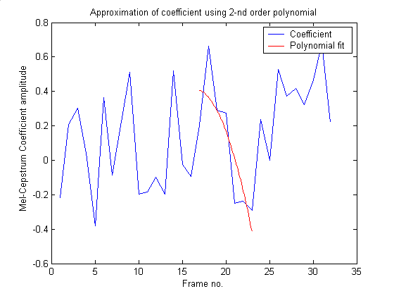
Figure 4.10
4.6 POSTPROCESSING
To achieve some enhancement in robustness there is a need for postprocessing of the coefficients.

4.6.1 Normalization

The enhancement done is a normalization, meaning that the feature vectors are normalized over time to get zero mean and unit variance. Normalization forces the feature vectors to the same numerical range [MM]. The mean vector, called 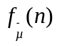, can be calculated according to Eq.4.14.

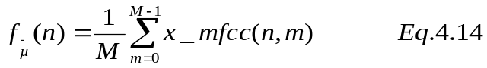

To normalize the feature vectors, the following operation is applied:
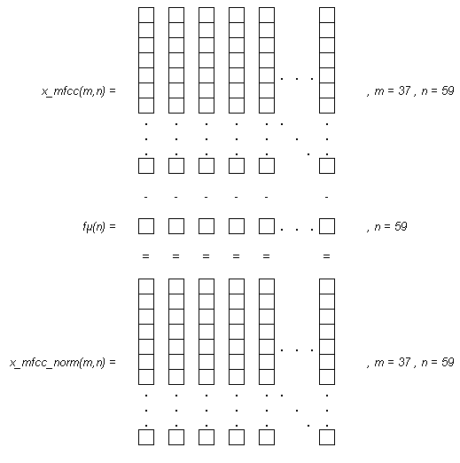
4.7 RESULT

4.7.1 Feature vectors – Mel Frequency Cepstrum Coefficients

The result, Mel Frequency Cepstrum Coefficients extracted from the utterance of ‘fram’:

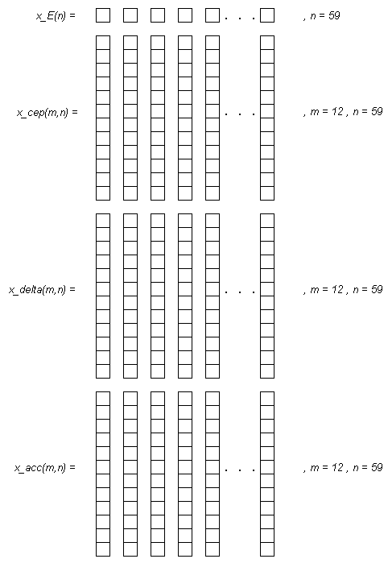

5. Hidden Markov Model

5.1 INTRODUCTION

As mentioned in the introduction part the technique used to implement the speech recognition system was the Hidden Markov Model, HMM. The technique is used to train a model which in our case should represent a utterance of a word. This model is used later on in the testing of a utterance and calculating the probability of that the model has created the sequence of vectors (utterance after parameterization done in chapter 4).

The difference between an Observable Markov Model and a Hidden Markov Model is that in the Observable the output state is completely determined at each time t. In the hidden Markov Model the state at each time t must be inferred from observations. An observation is a probabilistic function of a state. For further information about the difference and information about the Observable Markov Model and Hidden Markov Model please refer to [MM].

The hidden Markov Model is represented by λ = ( π, A, B ).

π = initial state distribution vector.

A = State transition probability matrix.

B = continuous observation probability density function matrix.

The three fundamental problems in the Hidden Markov Model design are the following[MM]:

Problem one - Recognition

Given the observation sequence O = (o1, o2,...,oT) and the model λ = ( π, A, B ), how is the probability of the observation sequence given the model, computed? That is, how is P(O|λ) computed efficiently?

Problem two - Optimal state sequence

Given the observation sequence O = (o1, o2,...,oT) and the model λ = ( π, A, B ), how is a corresponding state sequence, q = (q1, q2,...,qT), chosen to be optimal in some sense (i.e. best “explains” the observations)?

Problem three – Adjustment

How are the probability measures, λ = ( π, A, B ), adjusted to maximize P(O|λ)?

6. HMM – The training of a model of a word–The re-estimation problem

Given a N number of observation sequences of a word O_{N} = { o ₁ o ₂ o ₃ . . . . o _{T} }. How is the training of that model done to best represent the word. This is done by adjusting the parameters for the model λ = ( π, A, B ). The adjustment is an estimation of the parameters for the model λ = ( π, A, B ) that maximizes P(O|λ). The solution for this is the solutions of the first and third HMM problem [Rab89].

The sequence to create a HMM of a speech utterances is the following:

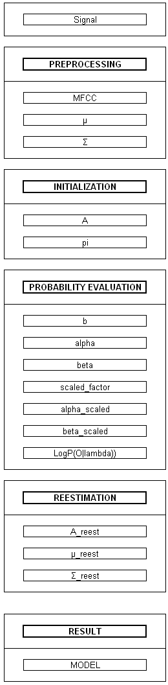
6.1 MEAN AND VARIANCE

6.1.1 Signal – The utterance

The signal used for training purposes are ordinary utterances of the specific word, the word to be recognized.

6.1.2 MFCC – Mel Frequency Cepstrum Coefficients

The MFCC matrix is calculated according to chapter 4 – Speech Signal to Mel Frequency Cepstrum Coefficients, see Figure 4.1 for a more detailed description. This is also used when testing an utterance against model, see chapter 7 – The testing of an observation.

6.1.3 μ, mean

When the MFCC is achieved, there is a need to normalize all the given training utterance. The matrix is divided into a number of coefficients times number of states. Then these are used for calculating the mean and variance of all the matrices, see section 4.1.4 for variance calculation. The mean us calculated using Eq6.1

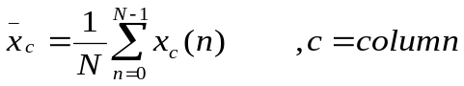 Eq.6.1

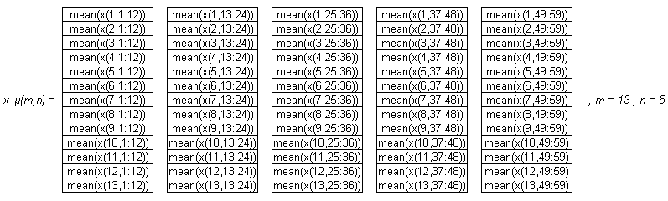
Note that if multiple utterances are used for training there is a need of calculating the mean of x_µ(m,n) for that number of utterances.

4.1.4 Σ, variance

The variance is calculated using Eq6.2 and Eq6.3.

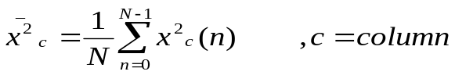Eq. 6.2

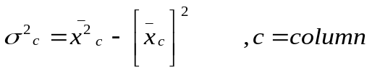 Eq. 6.3
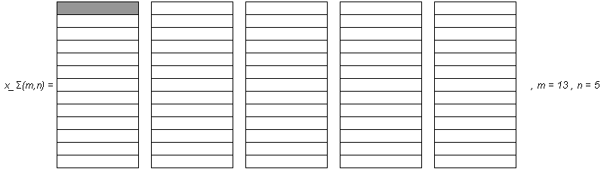
A more explicit example of calculating a certain index e.g the x_Σ(1,1) is done according to the following equation (the greyed element in x_Σ(m,n) ).

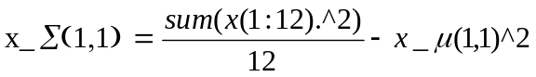 Eq. 6.4

6.2 INITIALIZATION

6.2.1 A, the state transition probability matrix, using the left-to-right model

The state transition probability matrix, A is initialized with the equal probability for each state.

A = 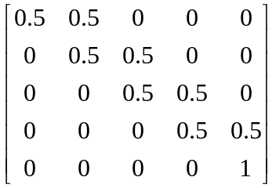

During the experimentation with the number of iterances within the reestimation of A the final estimated values of A where shown to deviate quite a lot from the beginning estimation. The final initialization values of A where initialized with the following values instead, which is more likely to the reestimated values (the reestimation problem is dealt with later on in this chapter.

A = 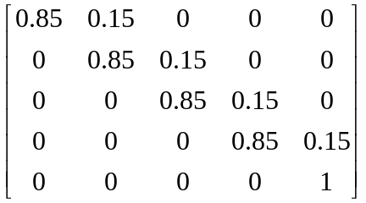

The change of initialization values is not a critical event thus the reestimation adjust the values to the correct ones according to the estimation procedure.

6.2.2 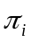, initialize the initial state distribution vector, using the left-to-right model
The initial state distribution vector is initialized with the probability to be in state one at the beginning, which is assumed in speech recognition theory[Rab]. It is also assumed that i is equal to five states in this case.

= 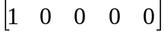 ,1 ≤ i ≤ number of states, in this case i = 5

6.3 MULTIPLE UTTERANCE ITERATION
6.3.1 B, the continuous observation probability density function matrix.

As mentioned in the Chapter 5 HMM - Hidden Markov Model, the complication of the direct observation of the state of the speech process is not possible there is need for some statistic calculation. This is done by introducing the continuous observation probability density function matrix, B. The idea is to that there is a probability of making a certain observation in the state, the probability that the model has produced the observed Mel Frequency Cepstrum Coefficients. There is a discrete observation probability alternative to use. This is less complicated in calculations but it uses a vector quantization which generates a quantization error. More of this alternative is to read in [Rab89].

The advantage with continuous observation probability density functions is that the probabilities are calculated direct from the MFCC without any quantization.

The common used distribution to describe the observation densities is the Gaussian one. This is also used in this project. To represent the continuous observation probability density function matrix, B the mean, μ and variance, Σ are used.

Due to that the MFCC are normally not frequency distributed a weight coefficient is necessary to use when the mixture of the pdf is applied. This weight coefficient, more the number of these weights is used to model the frequency functions which leads to a mixture of the pdf.

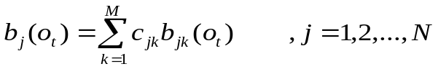
And M is the number of mixture weights, 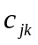. These are restricted due to
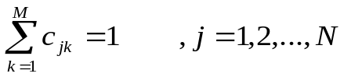

With the use of diagonal covariance matrices, due to the less computation and a faster implementation [MM], then the following formula is used.

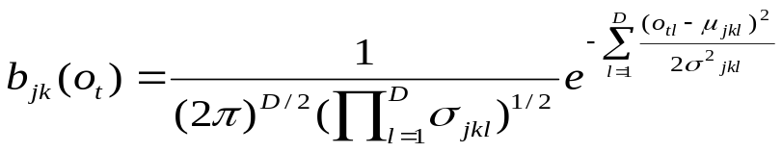Eq. 6.5

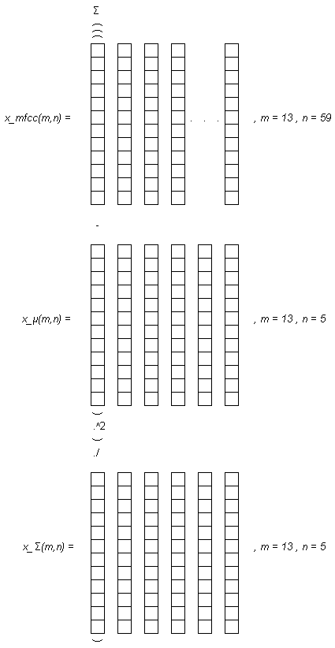

One x_mfcc feature vector is in the estimation versus each µ- and Σ vector. i.e. Each feature vector is calculated for all x_µ- and x_ Σ columns one by one.

The resulting state-dependent observation symbol probabilities matrix. The columns gives the observation probabilities for each state.
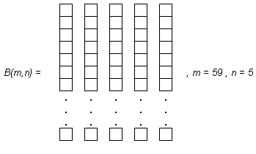

6.3.2 α, The Forward Algorithm

When finding the probability of an observation sequence O = { o₁ o₂ o₃ . . . . o_{T} } given a model λ = ( π, A, B ) you need to find the solution to problem one, probability Evaluation [Rab89]. The solution is about finding which of the models (assuming that they exist) that most likely has produced the observation sequence.

The natural way to do this is to evaluate every possible sequence of states of length T and then add these together.

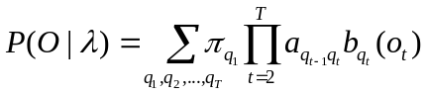 Eq 6.6

The interpretation of this equation is given in [MM] [David][Rab89]. It is the following:

Initially (at time t=1) we are in state q ₁ with probability 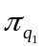, and generate the symbol 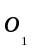with probability 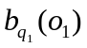the clock changes from t to t + 1 and a transition from q ₁ to q ₂ will occur with probability 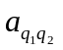, and the symbol 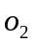will be generated with probability 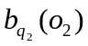. The process continues in this manner until the last transition is made (at time T), i.e., a transition from 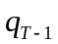to 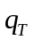will occur with probability 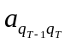, and the symbol 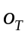will be generated with probability 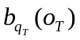.

The number of computations are extensive and have an exponential growth as a function of sequence length T. The equation is 2T * N^{T} calculations [Rab89]. When using this equation with 5 states and 100 observations gives you approximately 10⁷² computations. As this amount of computations is very demanding it is necessary to find a way to reduce this amount. This is done by using The Forward Algorithm.

The Forward Algorithm is based on the forward variable 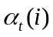, defined by

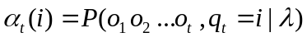

The definition of is that is the probability at time t and in state i given the model, having generated the partial observation sequence from the first observation until observation number 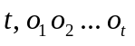. The variable can be calculated inductively according to Figure 6.1

Figure 6.1 [MM] 222222

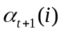 can be calculated by summing the forward variable for all N states at time t multiplied with their corresponding state transition probability and by the emission probability 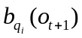. The procedure of calculating the forward variable, which can be computed at any time 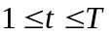is shown below.

- Initialization
Set t = 1;
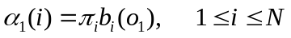
In the initialization step the forward variable gets its start value, which is defined as the joint probability of being in state 1 and observing the symbol 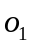. In left-to-right models only 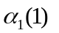will have a nonzero value.
- Induction
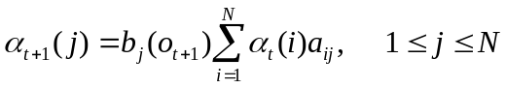
According to the lattice structure in Figure 6.1
- Update time
Set t = t + 1;
Return to step 2 if t ≤ T;
Otherwise, terminate the algorithm (goto step 4).
- Termination

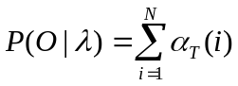

As mentioned before in an example according to the number of computations of the any path which gave a number of 10⁷² calculations with 5 states and 100 observations. When use of the forward algorithm the number of multiplications will be N(N+1)(T-1) + N and N(N-1)(T-1) additions. With 5 states and 100 observations it will give 2975 multiplications and 1980 additions, to compare with the direct method(any path) which gave 10⁷² calculations.

6.3.3 β, Backward Algorithm

If the recursion described to calculate the forward variable is done in the reverse way, you will get 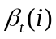, the backward variable. This variable is defined with the following definition:

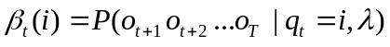

The definition of is that is the probability at time t and in state i given the model, having generated the partial observation sequence from t+1observation until observation number 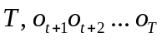. The variable can be calculated inductively according to Figure 6.2.

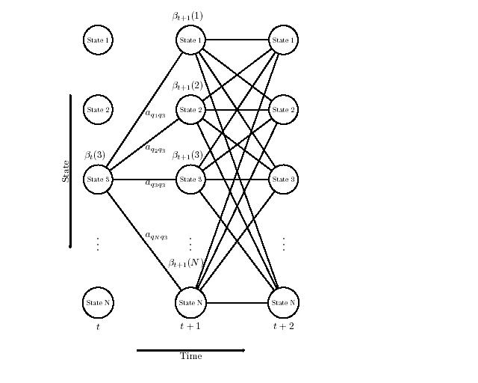

Figure 6.2 [MM]

- Initialization

Set t = T – 1;

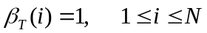

- Induction

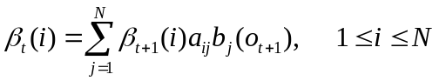
- Update time

Set t = t - 1;
Return to step 2 if t ≥ 0;
Otherwise, terminate the algorithm.

4.3.4 c, the scaling factor, α scaled, β scaled

Due to the complexity of precision range when calculating with multiplications of probabilities makes a scaling of both α and β necessary. The complexity is that the probabilities is heading exponentially to zero when t grows large. The scaling factor for scaling both the forward and backward variable is dependent only of the time t and independent of the state i. The notation of the factor is and is done for every t and state i, 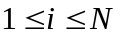. Using the same scale factor is shown useful when solving the parameter estimation problem (problem 3 [Rab89]), where the scaling coefficients for α and β will cancel out each other exactly.

The following procedure shows the calculation of the scale factor which as mentioned is also used to scale β. In the procedure the denotation 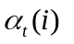is the unscaled forward variable, 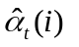denote the scaled forward variable and 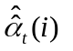denote the temporary forward variable before scaling.

- Initialization

Set t =2;
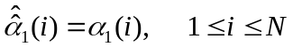
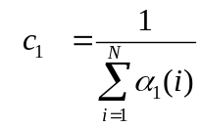
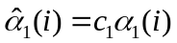
- Induction

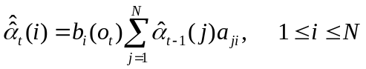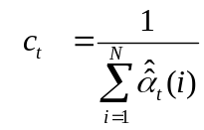

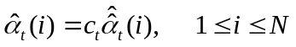

- Update time
Set t = t + 1;
Return to step 2 if t ≤ T;
Otherwise, terminate the algorithm (goto step 4).

- Termination

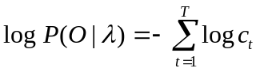

The use of the logarithm in step 4 is used due to the precision range and it is only used in comparising with other probabilities in other models.

The following procedure shows the calculation of the scaled backward variable using the same scale factor as in the calculation of the scaled forward variable. In the procedure the denotation 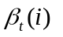is the unscaled backward variable, 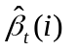denote the scaled backward variable and 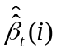denote the temporary backward variable before scaling.

- Initialization

Set t =T - 1;

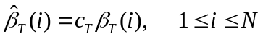
- Induction

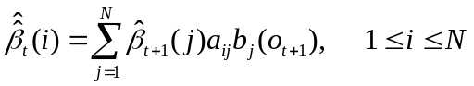

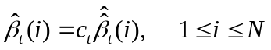
- Update time

Set t = t - 1;
Return to step 2 if t > 0;
Otherwise, terminate the algorithm.

The resulting alpha_scaled:

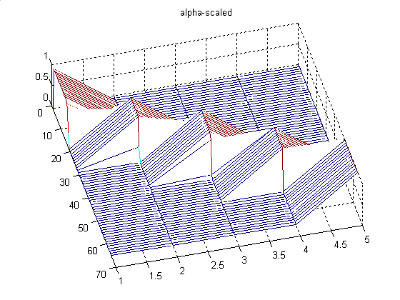

Figure 6.3

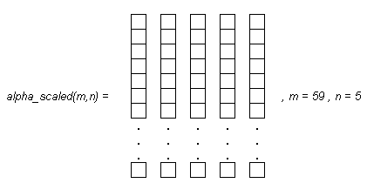

The resulting beta_scaled:

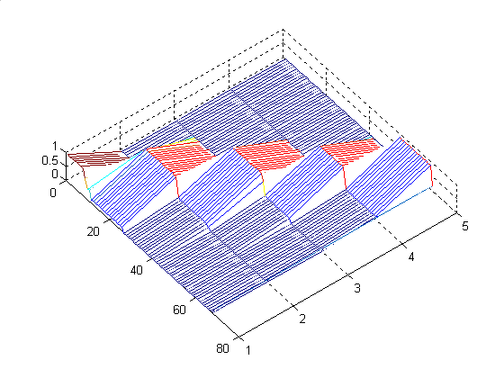

Figure 6.4

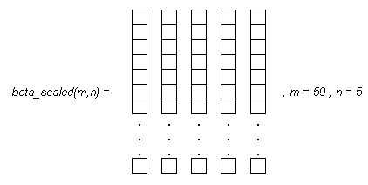

6.3.5 Log (P(O|λ)), save the probability of the observation sequence

The log(P(O| λ)) is saved in a matrix to see the adjustment of the restimation sequence.
For every iteration there is a summation of the sum(log(scale)), total probability. This summation is compared to the previous summation in previous iteration. If the difference between the measured values is less than a threshold, then an optimum can be assumed to have been reached. If necessary a fixed number of iterations could be set to reduce calculations.

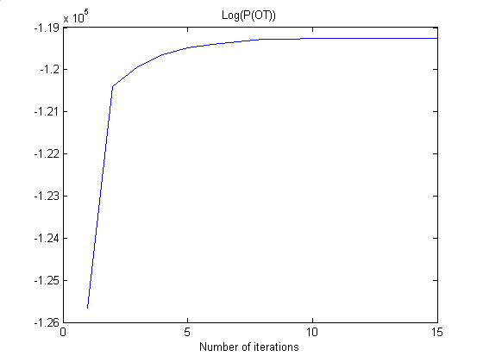
Figure 6.5
6.4 RE-ESTIMATION OF THE PARAMETERS FOR THE MODEL, λ = ( π, A, B )

The recommended algorithm used for this purpose is the iterative Baum-Welch algorithm that maximizes the likelihood function of a given model λ = ( π, A, B ) [MM][Rab][David]. For every iteration the algorithm reestimates the HMM parameters to a closer value of the “global” (exist many local) maximum. The importance lies in that the first local maximum found is the global, otherwise an erroneous maximum is found.

The Baum-Welch algorithm is based on a combination of the forward algorithm and the backward algorithm.

The quantities needed for the purpose of Baum-Welch algorithm are the following:

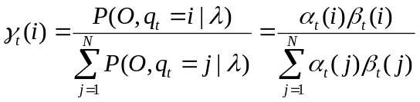

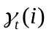 - The probability of being in state i at time t given the observation sequence and the model.

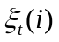 - The probability of being in state i at time t and being in state j at time t+1 given the observation sequence and the model.

The connection between and is the following:

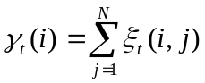
If the gamma variable is summed over time from t=1 to t=T-1 we get the expected number of times transitions are made from state i to any other state or back to itself.

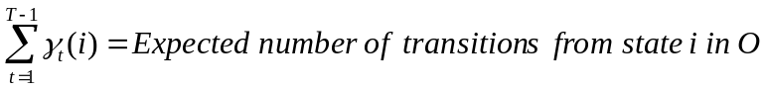

The equations needed for the reestimation are the following:

6.4.1 A_reest, reestimate the state transition probability matrix

When solving problem three, Optimize model parameters [Rab89], an adjustment of the parameters of the model is done. The Baum-Welch is used as mentioned in the previous section of this chapter. The adjustment of the model parameters should be done in a way that maximizes the probability of the model having generated the observation sequence.

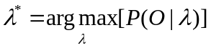
The ξ variable is calculated for every word in the training session. This is used with the γ variable which is also calculated for every word in the training session. Which means that we have two (nr of words * samples per word large) γ matrix. The following equation is used.

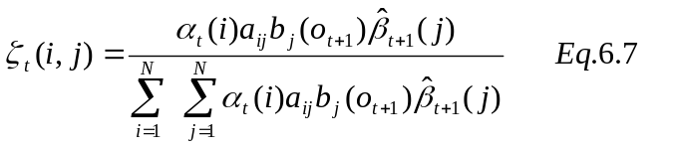

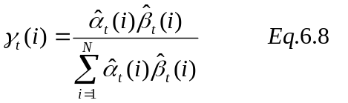

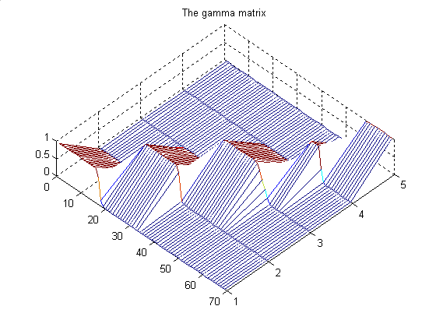
Note that there are no difference in using the scaled α and β or the unscaled. This is due to the dependency of time and not of state.

The reestimation of the A matrix is quite extensive due to the use of multiple observation sequences. For the collection of words in the training session there is calculated an average estimation with contribution from all utterances used in training session. The following equation is used.
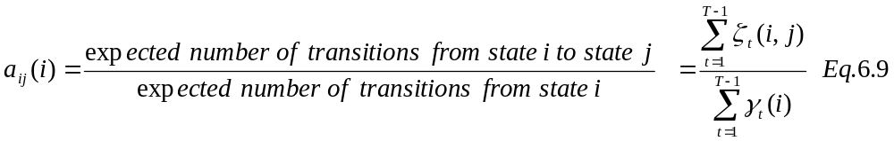

6.4.2 μ_reest, reestimated mean

A new x_μ(m,n) is calculated which is then used for the next iteration of the process. Note that its the concatenated 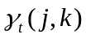that is used.
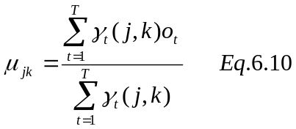
6.4.3 Σ_reest, reestimated covariance

A new x_Σ(m,n) is calculated which is then used for the next iteration. Note that its the concatenated that is used.

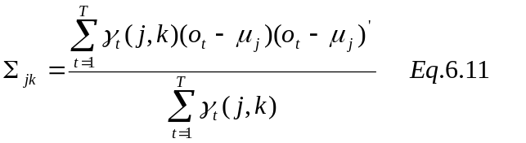

6.4.4 Check difference between previous iterated Log(P(OT) and the current one

A check is done on the difference between the previous iterated Log(P(OT)) and the current one. This is to see if the threshold value is obtained. Please recall Figure 6.5

6.5 THE RESULT – THE HIDDEN MARKOV MODEL

6.5.1 Save the Hidden markov Model for that specific utterance

After the reestimation is done. The model is saved to represent that specific observation sequences, i.e. an isolated word. The model is then used for recognition in next chapter – 7 Recognition. The model is represented with the following denotation λ = ( A, μ, Σ).

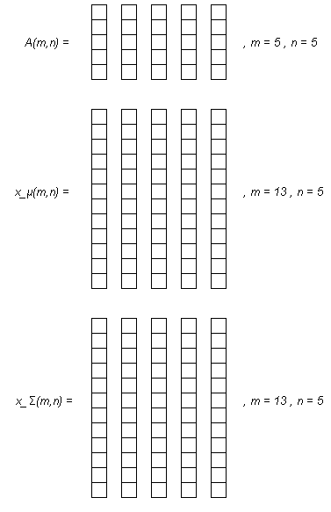
7. HMM – THE TESTING OF AN OBSERVATION – The decoding problem

When comparing an observation sequence O = { o₁ o₂ o₃ . . . . o_{T} } with a model λ = ( π, A, B ) you need to find the solution to problem two [Rab89]. The solution is about finding the optimal sequence of states q = { q₁ q₂ q₃ . . . . q_{T} } to a given observation sequence and model. There is different solutions depend on what is meant by optimal solution. In the case of most likely state sequence in its entirety, to maximize P (q|O, λ) the algorithm to be used is the Viterbi Algorithm [MM][David][Rab], state transition probabilities has been taken into account in this algorithm, which is not done when you calculate the highest probability state path. Due to the problems with the Viterbi Algorithm, multiplication with probabilities, The Alternative Viterbi Algorithm is used. The testing is done in such matter that the utterance to be tested is compared with each model and after that a score is defined for each comparison.
The flowchart for this task is given below.
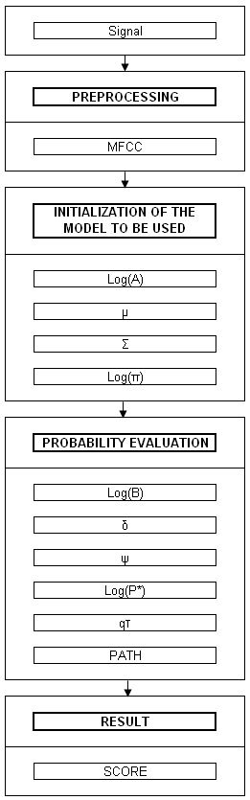

7.1 SPEECH SIGNAL

7.1.1 Speech signal

The signals used for testing purposes are ordinary utterances of the specific word, the word to be recognized.

7.2 PREPROCESSING

7.2.1 MFCC – Mel Frequency Cepstrum Coefficients

The MFCC matrix is calculated according to chapter 4 – Speech Signal to Feature Vectors. This is also used when training a model with utterance, see chapter 6 – HMM – The training of a model.

7.3 INITIALIZATION

7.3.1 Log(A), state transition probability matrix of the model

Because The Alternative Viterbi Algorithm is used instead of the Viterbi Algorithm is that The Viterbi Algorithm includes multiplication with probabilities. The Alternative Viterbi Algorithm does not, instead the logarithm is used on the model parameters. Otherwise the procedure is the same. Due to the use of left-to-right model there are zero components in the A and π. The use of logarithm on these causes problem, the zero components turns to minus infinity. To avoid this problem you have to add a small number to each of the zero components. In Matlab realmin(smallest value on computer) value can be used.

7.3.2 µ, mean matrix from model

Load the µ values from the trained model λ.

7.3.3 Σ, variance matrix from model

Load the Σ values from the trained model λ.

7.3.2 Log(π), initial state probability vector

As mentioned in the Log(A_model) section. A small number is added to the elements that contains a zero value. The π is the same for each model, remember the initialization of π due to the fact that it is used in a speechapplication.

7.4 PROBABILITY EVALUATION Loglikelihood, using
The Alternative Viterbi Algorithm

7.4.1 Log(B)

The continuous observation probability density function matrix is calculated as i the previous chapter – HMM – The training of a model. The difference is that the logarithm is used on the matrix due to the constraints of The Alternative Viterbi Algorithm.

7.4.2 δ, delta

To be able to search for the maximization of a single state path the need for the following quantity δ _{t} (i), is necessary.

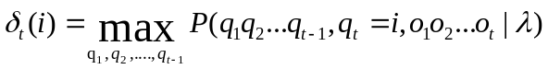 Eq 7.1
The quantity δ _{t} (i) is the probability of observing o₁ o₂ o₃ . . . . o_{t} using the best path that ends in state i at time t, given the model. Thus by induction the value for δ _{t+1} (i) can be retrieved.

Eq 7.2
7.4.3 ψ, psi

The optimal state sequence is retrieved by saving the argument which maximizes δ _{t+1} (j), this is saved in a vector ψ _{t} (j) [1][Rab89]. Note that when calculating b _{j} (o _{t}) the μ, Σ is gathered from the different models in comparison. The algorithm is processed for all models that the observation sequence should be compared with.

7.4.4 Log(P*)

Probability calculation of the most likely state sequence. The max argument on the last state

7.4.5 qT

Calculating the state which gave the largest Log(P*) at time T. Used in backtracking later on.

7.4.6 Path

State sequence backtracking. Find out the optimal state sequence using the ψt calculated in the induction part.

7.4.7 Alternative Viterbi Algorithm

The following steps are included in the Alternative Viterbi Algorithm [1] [2] [Rab89].

- Preprocessing
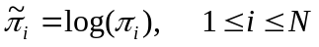 4.74 MM
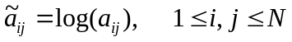4.75 MM

- Initialization
Set t = 2;
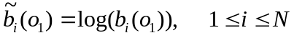4.76 MM
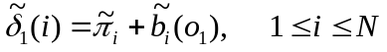4.77 MM
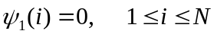4.78 MM

- Induction

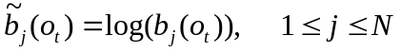4.79 MM
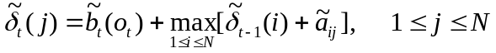4.80M
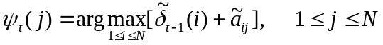4.81 MM

- Update time
Set t = t + 1;
Return to step 3 if t ≤ T;
Otherwise, terminate the algorithm (goto step 5).
- Termination

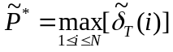 4.82 MM
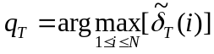 4.83 MM

- Path (state sequence) backtracking

  - Initialization
Set t = T - 1;
  - Backtracking
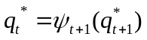 4.84 MM
  - Update time
Set t = t – 1;
Return to step b if t ≥ 1;
Otherwise, terminate the algorithm.

To exemplify how the Alternative Viterbi Algorithm works an example is given from [MM].

Consider a model with N = 3 states and an observation of length T = 8. In the initialization (t = 1) is δ ₁ (1), δ ₁ (2) and δ ₁ (3) found. Lets assume that δ ₁ (2) is the maximum. Next time (t = 2) three variables will be used namely δ ₂ (1), δ ₂ (2) and δ ₂ (3). Lets assume that δ ₂ (1) is now the maximum. In the same manner will the following variables δ ₃ (3), δ ₄ (2), δ ₅ (2), δ ₆ (1), δ ₇ (3) and δ ₈ (3) be the maximum at their time, see Fig. 7.1.

Fig. 7.1 shows that the Viterbi Algorithm is working with the lattice structure.

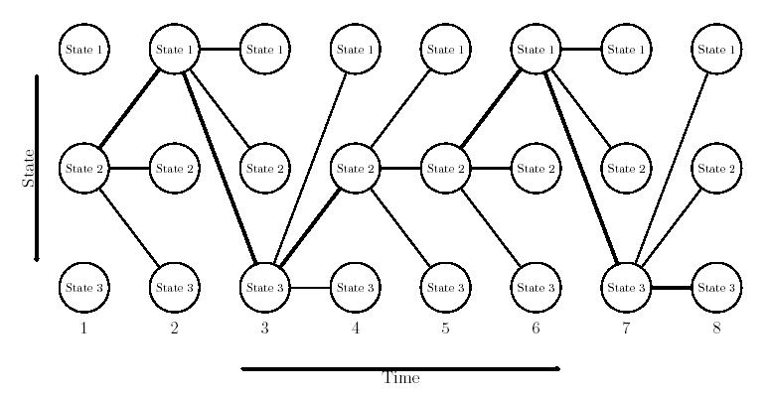

Figure 7.1 Example of Viterbi search

To find the state path the backtracking is used. It begins in the most likely end state and moves towards the start of the observations by selecting the state in the ψ _{t} (i) that at time t-1 refers to current state.

7.8 RESULT

7.8.1 Score
The score according to the Viterbi algorithm. The same as the calculated value Log(P*), the maximization of the probability of a single state path is saved as a result for each comparison. The highest score is naturally the highest probability that the compared model has produced the given test utterance.

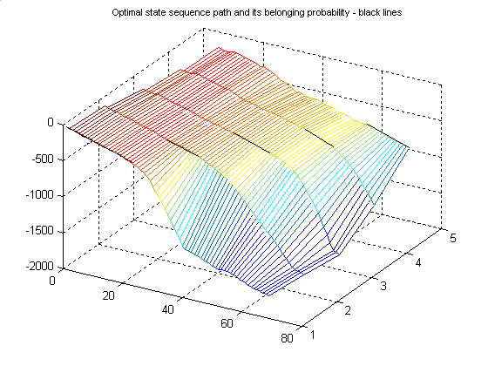
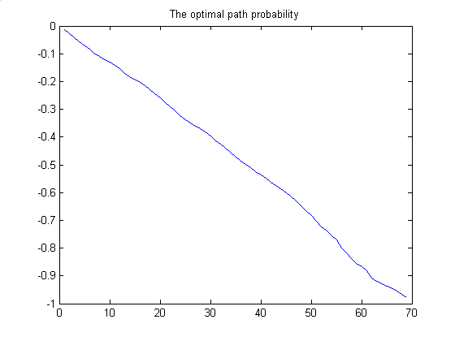
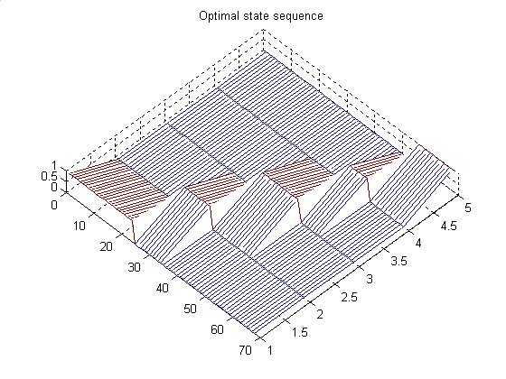
8 The BF533 DSP

8.1 The BF533 EZ-KIT Lite
The DSP used in this project is an BF533 EZ-KIT Lite, which is an fix point digital signal processor developed by Analog Devices. This DSP is offering a good performance at a very low power consumption. It have audio in/out ports as well as video in/out.
Main features
- Clock speed of 750MHz
- Audio ports, three in and two out
- Four 8-bit Video ALUs
- 40-bit shifter
- Dual 16-Bit multiplication accumulation (MAC)
- Friendly and easy to use compiler support.

The software used is Visual DSP++, also developed by Analog Devices.
All the programming on the BF-533 is done in programming language c.

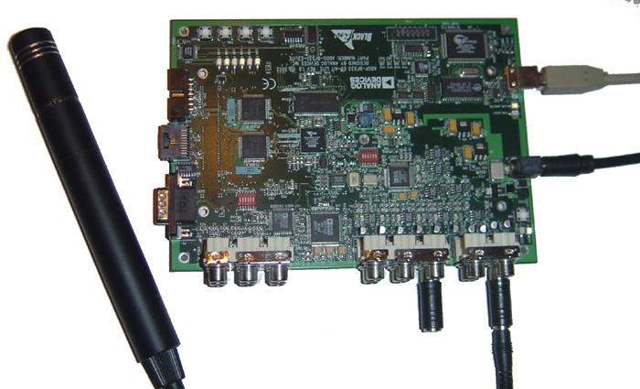

Figure 8.1

8.2 SPEECH SIGNAL
The human natural speech is collected to the DSP by a microphone connected to one of the audio connectors on the BF-533.

8.2.1 The talkthrough modification
To get started easier with the programming of the DSP, the test program Talkthrough provided together with the Visual DSP ++, is used. After implementing that and after testing that the audio in/out from the DSP is working we started the Speech Recognition Programming, based on the Talkthrough example.

8.2.2 Interrupts
The next issue to solve was to generate an interrupt by pushing a button on the BF-533.
For this, the example “Blink” provided with Visual DSP ++ is modified.
Interrupts are programmed in that way that every time one pushes a certain button, the Direct Memory Access Serial Port, DMA SPORT, is enabled and the DSP is listening for incoming speech signal from the microphone.
Next time the button is pushed the DMA SPORT is disabled and the speech recognition program begins.

8.2.2 DMA, Direct Memory Access
The DMA is a device for transferring data to or from other memory locations or peripherals (in our case microphone) without the attention of the CPU. DMA1 and DMA2 are mapped to SPORT_RX and SPORT_TX respectively, and are configured to use 16-bit transfers.

8.2.2 Filtering
The sampling frequency of A/D Converter on BF533 EZ-KIT Lite is 48 kHz. However the sampling frequency is decimated to 16 kHz. Decimation can be done without aliasing if we reduce the bandwidth of the signal before downsampling [John]. Input signal is filtered with a lowpass filter with cutoff frequency, 16 kHz, which is equal with the sampling frequency divided with by decimation factor.

The length of the input speech signal is limited due to the limits on the DSP internal memory. To avoid those limits we stored the input signal on the DSPs SDRAM. The allocated length of the input signal is chosen to be 36100 samples (approx. 2.3 seconds of speech).

When the input signal is collected, it had to have the same numerical range as the word-models where generated in matlab. Therefore the insignal is converted to float type and emphasized to a comparable magnitude range. In our case as c-code below:

x_length = 36100;
for (i=0;i < x_length; i++)
{
temp = (float)(test[i]);
temp2 = temp + 200;
x_in[i] = temp2/4000;
}

After applying those steps the computing of speech recognition could be started.
8.3 PREPROCESSING

8.3.1 Preemphasis
The filtering is done similarly as in matlab. Same filter is used

const float h[2] = {1,-0.97};

See Figure 8.1 for plot from the input signal before preemphasizing and Figure 8.2 after.
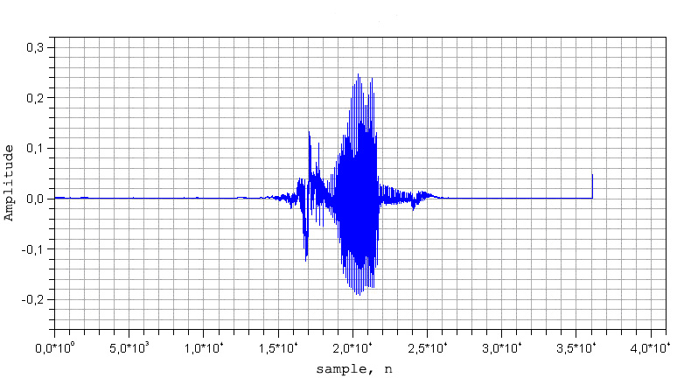

Figure 8.2 The signal x_utt(n) before preemphasis
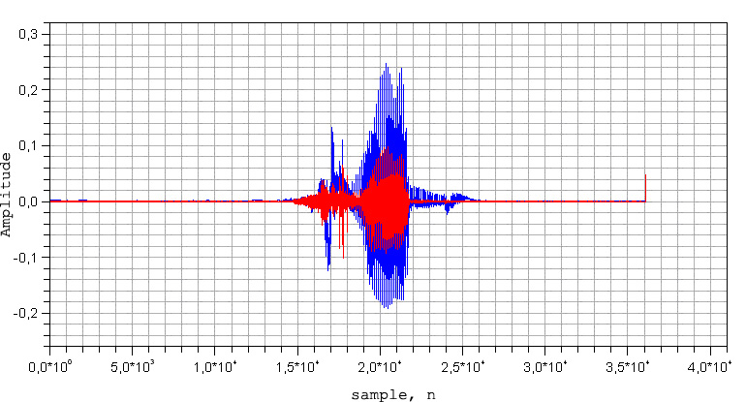

Figure 8.3 The blue signal x_utt(n),and the preemphasized red signal, x_preemp(n)
8.3.2 Voice Activation Detection
When you have got access to a sampled discrete signal it is significant to reduce the data to contain only the samples which is represented with signal values, not noise. Therefore the need of a good Voice Activation Detection function is needed. There are many ways of doing this. Voice activation detection is calculated similarly as in matlab (chapter 4).

The variable alpha is though different from the matlab version. This variable is tuned due to another noise to ratio- and processing values compare to matlab environment.
See Eq. 8.1 for description of the function used.

Eq. 8.1

The threshold in our case where tested and tuned to 1.2 * t_{w}. The result of the preemphasized signal is presented in Figure 8.3.
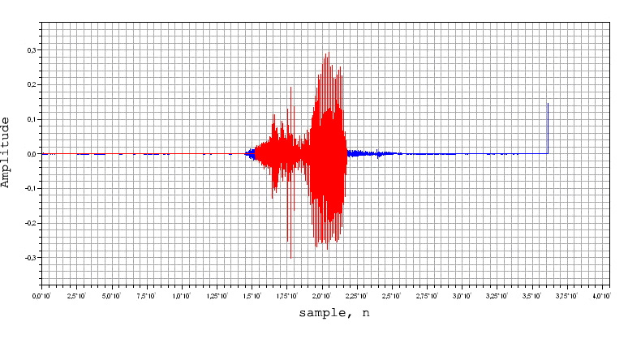
Figure 8.4 The VAD applied to the signal

8.4 FRAMEBLOCKING & WINDOWING

8.4.1 Frameblocking
The filtering is done similarly as in matlab. The frame length is 320 and an overlap of 60,9% is used. Figure 8.4 illustrates frame 20 after frameblocking.

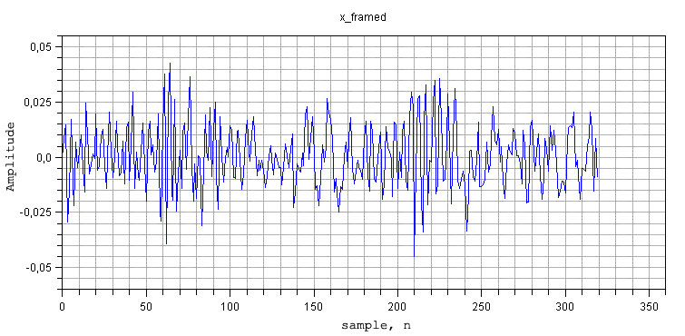

Figure 8.5

8.4.2 Windowing using Hamming window
After the frameblocking is done a Hammingwindow is applied to each frame. This window is to reduce the signal discontinuity at the ends of each block. The formula used to apply the windowing is shown in Eq.3.3.

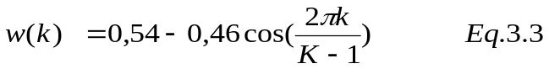

Figure 8.5 illustrates frame 20 after windowing. Note that the result gives a reduction of the discontinuity at the ends of the block.

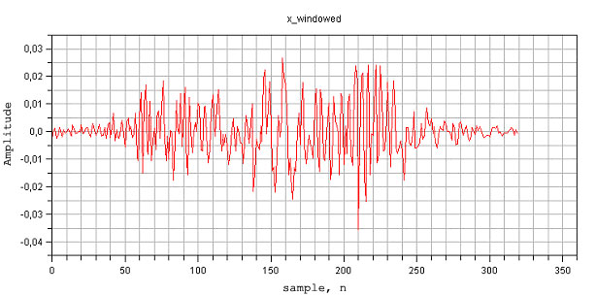

Figure 8.6

  - FEATURE EXTRACTION
A 512 pont FFT is used on each windowed frame. To adjust the length, zeropadding is used. Se figure 7.7.

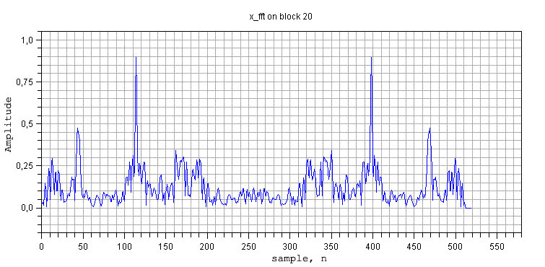
Figure 8.7

The function fft256.c [book], is modified in order to calculate the fft for the signal after windowing. Exactly the same filterbank as in matlab is used. See chapter 3.4.2 “Mel spectrum coefficients with filterbank”. Mel-Cepstrum coefficients are calculated using Eq. 3.6. A low-time lifter is then used in order to remove the first two coefficients using formula in Eq. 3.7.
An extra coefficient which contains the log of signal energy is added for each frame, as shown in Eq. 3.9.

  - FEATURE VECTORS – Mel Frequency Cepstrum Coefficients
The result: Mel Frequency Cepstrum Coefficients, MFCC
8.7 TESTING
The models created as we described in chapter 5 are now stored in the DSP memory. After we processed the input speech from the microphone to the Mel Frequency Cepstrum Coefficients, MFCC, we now have to test the input word with each of the stored models λ = ( π, A, B ). The whole flowchart of testing of the word can be seen on Figure 8.8.

Figure 8.8

To maximize P (q|O, λ) the algorithm to be used is the Alternative Viterbi Algorithm [4]. The testing is done in such matter that the utterance to be tested is compared with each model and after that a score is defined for each comparison.

8.8 INITIALIZATION OF THE MODEL TO BE USED

8.8.1 Log(A), state transition probability matrix of the model
Due to the constrains of the Viterbi Algorithm the logarithm is used on modelparameters A. As we mentioned before in chapter 6 – HMM Testing where any value of A is zero we set a very low number in stead of zero to avoid log(0) which is minus infinity.

8.8.2 µ, mean matrix from model
Load the µ values from the trained model λ.

8.8.3 Σ, variance matrix from model
Load the Σ values from the trained model λ.

8.8.4 Log(π), initial state probability vector
Even the log(π) is calculated as mentioned in chapter 6, even here a very small number is set in stead of zero.

8.9 PROBABILITY EVALUATION Loglikelihood, using The Alternative Viterbi Algorithm

8.9.1 Log(B)
The continuous observation probability density function matrix is calculated as in chapter 6 – HMM – The training of a model, Eq. 4.17. Due to the constrains of the Viterbi Algorithm the logarithm is used on B.

8.9.2 δ, delta
The quantity δ _{t} (i) is the probability of observing o₁ o₂ o₃ . . . . o_{t} using the best path that ends in state i at time t, given the model.
δ _{t} (i) is calculated similarly as in matlab, using Eq 7.1 and Eq 7.2

8.9.3 ψ, psi
The optimal state sequence ψ _{t} (j) is calculated similarly as in matlab

8.9.4 Log(P*)
Calculating the probability of the most likely state sequence. The max argument on the last state.

8.9.5 qT
Calculating the state which gave the largest Log(P*) at time T. Used in backtracking later on.
8.9.6 Path
State sequence backtracking. Find out the optimal state sequence using the ψt calculated in the induction part.

8.9.7 Alternative Viterbi Algorithm
The following steps of the Alternative Viterbi Algorithm, are calculated similarly as in matlab and described on chapter 7.4.7 Alternative Viterbi Algorithm.

- Preprocessing
4.74 MM
4.75 MM

- Initialization
Set t = 2;
4.76 MM
4.77 MM
4.78 MM

- Induction

4.79 MM
4.80M
4.81 MM

- Update time
Set t = t + 1;
Return to step 3 if t ≤ T;
Otherwise, terminate the algorithm (goto step 5).
- Termination

4.82 MM
4.83 MM

- Path (state sequence) backtracking

  - Initialization
Set t = T - 1;
  - Backtracking
4.84 MM
  - Update time
Set t = t – 1;
Return to step b if t ≥ 1;
Otherwise, terminate the algorithm.

8.10 DELTA & ACCELERATION COEFFICIENTS
The delta and acceleration coefficients are calculated to increase the information of the human perception. The delta coefficients are about time difference, the acceleration coefficients are about the second time derivative.
Delta and acceleration coefficients are though not used when implementing the Speech recognition in DSK, because of its small effect in the final result.
Another reason for not using the delta & acceleration coefficients in DSK is to save power from processor and to shorten the calculation time.

8.11 THE RESULT
8.11.1 The Score
The score from each stored model tested towards the input word is stored in a result vector. The highest score is naturally the highest probability that the compared model has produced the given test utterance.

Depending of which the score was, we turn on different LEDs on the BF533.
word | LEDs | LEDs on DSP
“one” | 000001 | □□□□□■
“two” | 000010 | □□□□■□
“three” | 000011 | □□□□■■
“four” | 000100 | □□□■□□
“five” | 000101 | □□□■□■

9. Evaluation

9.1 MATLAB

9.1.1 MatLab Result

The MatLab result is given in Table 1, Table 2, Table 3, Table 4 and Table 5. The different tables shows the score for the different models to be the one generating the utterances tested.
The number of utterances tested are 50 times 5 (5 different words). There is a recognition rate of 100%.
The following columns are the result score from testing utterances of ‘one’ against the different models.

1.0e+003 *
‘one’ ‘two’ ‘three’ ‘four’ ‘five’
-0.9770 -2.9766 -3.2583 -2.2377 -2.5070
-1.0086 -3.1571 -3.2334 -2.5384 -2.6038
-0.8504 -2.9012 -2.9939 -2.1566 -2.0795
-0.9443 -2.6649 -2.9332 -2.1653 -2.2754
-0.9467 -3.0241 -3.1812 -2.5634 -2.4507
-0.8940 -2.9874 -3.1127 -2.3956 -2.4391
-0.9386 -2.5942 -2.9423 -2.3368 -2.5228
-0.8825 -2.6087 -2.8463 -2.4483 -2.3978
-0.8586 -2.7028 -2.9389 -2.2648 -2.3426
-0.7950 -2.5843 -2.6597 -2.2132 -1.9123
-0.8523 -2.6194 -2.7973 -2.4924 -2.0237
-0.9398 -2.7593 -2.7188 -2.3597 -2.2943
-0.9251 -2.7752 -3.1590 -2.7397 -2.5636
-0.9718 -2.9325 -3.2498 -2.6431 -2.6311
-0.8737 -2.7661 -3.1350 -2.5092 -2.4376
-0.9355 -2.9730 -3.1797 -2.8348 -2.3790
-0.9305 -2.7916 -2.8847 -2.8549 -2.2437
-0.9332 -2.7710 -3.0431 -2.7362 -2.4466
-0.9368 -3.0491 -3.3389 -2.6097 -2.5303
-0.8596 -2.8274 -2.8630 -2.1620 -2.3963
-0.9110 -2.9492 -2.9199 -2.1652 -1.9718
-0.8051 -2.8448 -2.9742 -2.0679 -2.2819
-0.8597 -2.8761 -2.9300 -2.0903 -2.3264
-0.8809 -3.1850 -3.1918 -2.3860 -2.3666
-0.7885 -2.4771 -2.4799 -2.0925 -1.9500
-0.8613 -2.6787 -2.7539 -2.3984 -2.1103
-0.8644 -2.7467 -2.9409 -2.2356 -2.5205
-0.8962 -2.6071 -2.8487 -2.5541 -2.0202
-0.8010 -2.5107 -2.6974 -2.4216 -2.0117
-0.7426 -2.2532 -2.2583 -1.8565 -1.5876
-1.0010 -2.8094 -3.2577 -2.3076 -2.8508
-0.9827 -2.9553 -3.1397 -2.1257 -2.4699
-0.9799 -3.0520 -3.0455 -2.4637 -2.4989
-0.9237 -3.0867 -3.1147 -2.1364 -2.0204
-0.9549 -2.8912 -2.9531 -2.0862 -2.4049
-1.0763 -3.4107 -3.4638 -2.2895 -2.4884
-1.0339 -3.4492 -3.4761 -2.2683 -2.6357
-0.9345 -3.0110 -2.8431 -2.0937 -2.0289
-1.0805 -3.6430 -3.5430 -2.9408 -2.6812
-1.2520 -4.0098 -3.9728 -3.0751 -2.8562
-1.1151 -3.2686 -3.2906 -2.7100 -2.5772
-0.9424 -3.2784 -3.1182 -2.3509 -2.2908
-1.0198 -3.3099 -3.1879 -2.2265 -2.4441
-0.9168 -2.9677 -2.9726 -2.2570 -2.5099
-1.0924 -3.5614 -3.4578 -2.8927 -2.6202
-1.0045 -3.2830 -3.0953 -2.5430 -2.4347
-1.0560 -3.2444 -3.2417 -2.6254 -2.7030
-1.0802 -3.3851 -3.4595 -2.4772 -2.3394
-0.9557 -3.2024 -3.2659 -2.3698 -2.3896
-1.1137 -3.4744 -3.5221 -2.5851 -2.7202
Table 9.1
The first column always shows the highest score. Means that the recognition rate for the utterance ‘one’ is 100% of the 50 utterances tested.
The following columns are the result score from testing utterances of ‘two’ against the different models.

1.0e+003 *
‘one’ ‘two’ ‘three’ ‘four’ ‘five’
-1.8271 -0.6796 -1.3686 -2.1710 -1.4022
-1.5456 -0.6997 -1.4461 -2.2211 -1.2491
-1.8576 -0.6777 -1.2135 -2.1087 -1.3004
-1.5572 -0.6432 -1.1511 -2.1250 -1.1618
-1.5681 -0.6293 -1.2130 -1.9162 -1.2072
-1.7089 -0.6621 -1.2468 -2.2219 -1.2808
-1.6364 -0.6876 -1.5123 -2.5024 -1.4315
-1.6478 -0.6041 -1.3093 -2.2707 -1.4233
-1.9740 -0.6766 -1.2982 -2.3318 -1.5201
-1.8500 -0.6755 -1.2313 -2.1558 -1.3031
-1.8211 -0.7112 -1.4090 -2.2684 -1.4574
-1.6911 -0.6700 -1.3886 -2.4680 -1.4400
-1.7892 -0.6959 -1.4408 -2.6182 -1.4791
-1.7646 -0.7113 -1.3424 -2.2388 -1.4257
-1.2233 -0.5567 -1.1985 -1.8783 -1.0970
-1.3697 -0.6726 -1.4301 -2.1417 -1.2601
-1.4729 -0.6596 -1.3037 -2.1249 -1.2695
-1.7165 -0.6965 -1.5028 -2.2498 -1.4016
-1.5379 -0.7125 -1.5122 -2.3982 -1.3826
-1.4405 -0.7260 -1.3757 -2.3133 -1.3032
-1.4423 -0.6377 -1.3120 -2.0337 -1.2413
-1.5858 -0.5933 -1.2084 -2.1681 -1.2777
-1.6119 -0.7008 -1.3634 -2.3734 -1.2953
-1.5128 -0.7162 -1.4583 -2.5157 -1.2719
-1.3705 -0.6440 -1.3106 -2.0868 -1.1870
-1.5257 -0.6493 -1.3938 -2.2695 -1.2400
-1.6278 -0.6615 -1.4295 -2.3829 -1.3833
-1.8694 -0.6270 -1.2640 -2.3162 -1.3246
-1.7272 -0.6679 -1.2359 -2.1135 -1.2319
-1.3631 -0.5805 -1.1283 -1.9322 -1.0457
-1.4262 -0.6276 -1.3211 -2.0577 -1.0913
-1.5983 -0.6013 -1.1532 -2.1034 -1.3433
-1.6410 -0.5810 -1.1478 -1.8979 -1.1988
-1.6082 -0.5787 -1.1230 -1.9315 -1.2243
-1.7776 -0.6809 -1.3323 -2.2312 -1.2988
-1.7040 -0.7330 -1.3433 -2.0454 -1.4311
-2.2071 -0.7663 -1.2819 -2.4617 -1.5456
-2.0144 -0.6845 -1.3437 -2.3749 -1.4631
-2.1379 -0.7047 -1.3746 -2.6290 -1.6026
-1.8879 -0.6748 -1.2290 -2.2582 -1.4050
-1.8802 -0.6806 -1.2039 -1.9917 -1.4384
-2.0292 -0.7238 -1.4331 -2.2058 -1.6078
-1.6255 -0.6148 -1.2261 -1.9218 -1.2323
-1.9322 -0.6486 -1.1870 -2.1152 -1.2659
-2.1167 -0.6611 -1.2098 -2.0719 -1.3487
-1.7757 -0.6584 -1.3346 -1.9878 -1.2651
-1.8599 -0.6019 -1.1106 -2.0953 -1.1806
-1.8270 -0.6436 -1.1599 -1.9857 -1.3664
-1.9272 -0.6510 -1.2044 -2.2459 -1.4605
-1.9440 -0.6776 -1.2265 -2.2386 -1.4228
Table 9.2
The first column always shows the highest score. Means that the recognition rate for the utterance ‘two’ is 100% of the 50 utterances tested.
The following columns are the result score from testing utterances of ‘three’ against the different models.

1.0e+003 *
‘one’ ‘two’ ‘three’ ‘four’ ‘five’
-2.8178 -1.5243 -0.7647 -2.5438 -1.5706
-2.5471 -1.3969 -0.7250 -2.3959 -1.4380
-2.5431 -1.6701 -0.8059 -2.7828 -1.7424
-1.7496 -1.0409 -0.5471 -2.0329 -1.1785
-2.5429 -1.4456 -0.6547 -2.5089 -1.5081
-2.1500 -1.2552 -0.6398 -2.4129 -1.3838
-2.3398 -1.3406 -0.6324 -2.3714 -1.4428
-2.8475 -1.5890 -0.6764 -2.4922 -1.5226
-2.7630 -1.4673 -0.7139 -2.5405 -1.5308
-3.2249 -1.6659 -0.9033 -2.6988 -1.7644
-2.6718 -1.4984 -0.7217 -2.5533 -1.5691
-2.5804 -1.6122 -0.6568 -2.5701 -1.6272
-2.5651 -1.4354 -0.6163 -2.0643 -1.3524
-2.8130 -1.5426 -0.7333 -2.4413 -1.5001
-2.8571 -1.6705 -0.7764 -2.7875 -1.6261
-2.3100 -1.3185 -0.6434 -2.3143 -1.3187
-3.3875 -1.7667 -0.7808 -2.7141 -1.7132
-3.0448 -1.5897 -0.7071 -2.4737 -1.5387
-2.5144 -1.3510 -0.6505 -2.1212 -1.3792
-2.1561 -1.2215 -0.5817 -2.1467 -1.3409
-2.8858 -1.6538 -0.7806 -2.2758 -1.6248
-3.0073 -1.5497 -0.6639 -2.4306 -1.4322
-3.0726 -1.5419 -0.7516 -2.5357 -1.5470
-2.8669 -1.6614 -0.7701 -2.8823 -1.7392
-3.4247 -1.7979 -0.7150 -2.3990 -1.5776
-2.3734 -1.3703 -0.6395 -2.5316 -1.4631
-2.4231 -1.2908 -0.5989 -2.4402 -1.4127
-2.8196 -1.4800 -0.7748 -2.8288 -1.6756
-2.8650 -1.6949 -0.7208 -2.7558 -1.6875
-2.8087 -1.7231 -0.7591 -2.4927 -1.6629
-2.6726 -1.5529 -0.6873 -2.6632 -1.5836
-2.4262 -1.4763 -0.6082 -2.5749 -1.5175
-3.3488 -1.8869 -0.7511 -2.9427 -1.8408
-2.4204 -1.5335 -0.6743 -2.7674 -1.6578
-2.7438 -1.5754 -0.7364 -2.9417 -1.8357
-2.5678 -1.4683 -0.7097 -2.8104 -1.6848
-2.3208 -1.4071 -0.6852 -2.8056 -1.6661
-2.3763 -1.3318 -0.7111 -2.8282 -1.6328
-2.1578 -1.3594 -0.6290 -2.5144 -1.5743
-2.4479 -1.4778 -0.6918 -2.4328 -1.5393
-2.6115 -1.7402 -0.7247 -2.4765 -1.7171
-2.2605 -1.4494 -0.6641 -2.6239 -1.6191
-2.3225 -1.4010 -0.6427 -2.6237 -1.5836
-2.7742 -1.5776 -0.6569 -2.6290 -1.6636
-2.5696 -1.5441 -0.6448 -2.5704 -1.5582
-2.7002 -1.6280 -0.9598 -2.7101 -1.7464
-2.1392 -1.4196 -0.6399 -2.5257 -1.4521
-2.3673 -1.4991 -0.6276 -2.5039 -1.4864
-2.1857 -1.3629 -0.6522 -2.3978 -1.3939
-2.7003 -1.5578 -0.7474 -2.3574 -1.4567 Table 9.3
The first column always shows the highest score. Means that the recognition rate for the utterance ‘three’ is 100% of the 50 utterances tested.
The following columns are the result score from testing utterances of ‘four’ against the different models.

1.0e+003 *
‘one’ ‘two’ ‘three’ ‘four’ ‘five’
-2.3833 -3.1448 -2.4785 -0.8907 -1.8601
-2.8456 -3.3649 -2.7943 -1.0241 -2.0355
-2.2093 -2.7955 -2.3422 -0.8776 -1.9379
-2.4640 -3.3559 -2.7926 -0.9668 -2.0588
-0.6870 -2.4023 -2.3105 -0.6032 -1.6915
-2.2778 -3.0211 -2.5014 -0.9087 -1.9156
-1.2250 -2.4471 -2.5793 -0.6720 -1.8323
-1.0560 -2.7803 -2.6692 -0.6927 -2.0349
-1.0901 -2.3251 -2.1582 -0.6135 -1.6183
-0.8463 -2.0638 -1.8828 -0.5932 -1.4845
-1.0311 -2.4185 -2.1460 -0.6321 -1.5852
-2.9136 -3.1761 -2.7042 -1.0567 -2.0249
-1.8514 -2.6102 -2.3643 -0.8358 -1.7996
-1.4371 -2.5867 -2.3855 -0.6807 -1.8087
-1.1227 -2.5266 -2.6165 -0.6856 -1.8658
-2.3652 -3.1053 -2.8580 -0.9724 -2.1510
-1.2250 -2.4471 -2.5793 -0.6720 -1.8323
-1.0036 -2.7017 -2.7877 -0.7119 -2.0104
-2.0143 -2.9307 -2.9079 -0.8515 -2.0443
-0.9330 -1.7984 -1.8810 -0.6613 -1.2906
-1.7455 -2.4404 -2.2213 -0.7844 -1.7103
-1.1755 -2.7269 -2.7397 -0.6841 -1.9165
-0.9592 -2.5391 -2.6232 -0.6493 -1.8009
-1.8258 -2.9313 -2.8709 -0.8860 -2.0857
-1.4276 -2.6464 -2.4496 -0.7397 -1.8149
-1.9535 -2.8304 -2.4990 -0.8554 -1.9978
-0.9355 -2.5215 -2.5047 -0.6679 -1.8110
-2.4351 -2.2894 -1.5949 -0.8731 -1.4633
-0.9969 -2.3889 -2.2915 -0.6723 -1.7521
-1.1031 -2.2958 -2.2646 -0.6982 -1.6737
-0.8995 -2.3289 -2.1960 -0.5928 -1.5710
-1.4758 -2.6066 -2.4613 -0.7479 -1.8060
-1.2333 -2.8119 -2.7721 -0.7892 -1.6960
-0.9084 -2.3313 -2.3373 -0.6111 -1.6497
-0.9730 -2.2159 -2.3079 -0.6117 -1.5132
-1.0382 -2.6066 -2.8560 -0.6829 -1.9087
-1.1706 -2.5037 -2.6458 -0.7302 -1.7326
-1.1197 -2.5512 -2.6011 -0.7034 -1.7229
-1.1685 -2.8590 -2.6970 -0.7471 -1.9670
-1.8115 -2.7222 -2.6761 -0.8459 -1.9692
-2.2670 -2.5476 -2.2720 -0.7672 -1.5356
-1.0610 -2.6325 -2.7014 -0.6881 -1.8688
-1.4570 -2.7595 -2.9342 -0.8165 -2.0168
-2.6749 -3.2145 -2.8560 -0.9854 -2.0778
-1.6566 -2.7105 -2.7858 -0.7710 -1.9260
-1.2923 -2.7367 -2.7840 -0.7340 -1.8695
-1.2053 -2.6242 -2.5971 -0.6752 -1.7708
-1.4385 -2.7700 -3.0330 -0.7923 -1.9664
-1.9711 -2.7082 -2.5714 -0.8514 -1.7514
-1.1727 -2.5524 -2.3131 -0.7083 -1.7348 Table 9.4
The first column always shows the highest score. Means that the recognition rate for the utterance ‘four’ is 100% of the 50 utterances tested.
The following columns are the result score from testing utterances of ‘five’ against the different models.

1.0e+003 *
‘one’ ‘two’ ‘three’ ‘four’ ‘five’
-1.5563 -2.0059 -1.6262 -1.8464 -0.7753
-2.0805 -1.9892 -1.3444 -1.4268 -0.7958
-1.7437 -2.0034 -1.7512 -2.3998 -0.8256
-1.2058 -1.4765 -1.1393 -1.0757 -0.5095
-1.4376 -1.4008 -1.1246 -0.9805 -0.5918
-1.0861 -1.3844 -1.2364 -1.1543 -0.5042
-1.3876 -1.5534 -1.2302 -1.2162 -0.5798
-1.5948 -1.7899 -1.5806 -1.5824 -0.6561
-1.9995 -1.7620 -1.2767 -1.1075 -0.6633
-1.8340 -1.9702 -1.6964 -1.8565 -0.7096
-2.6893 -2.6080 -2.3324 -2.8853 -1.0019
-1.2084 -1.4398 -1.2270 -1.1109 -0.5146
-1.3446 -1.6276 -1.4194 -1.8678 -0.6691
-1.7338 -1.8699 -1.6948 -1.9441 -0.7503
-1.0994 -1.4984 -1.3133 -1.1701 -0.5342
-1.3459 -1.6568 -1.6136 -1.9756 -0.6516
-1.0217 -1.4037 -1.1295 -1.2458 -0.5437
-2.0400 -2.3034 -2.1199 -2.7729 -0.9026
-1.2829 -1.6139 -1.4681 -1.9779 -0.7499
-2.2419 -2.1812 -1.6616 -1.6570 -0.8441
-1.3098 -1.6599 -1.6159 -1.7473 -0.6977
-1.8816 -1.8707 -1.3966 -1.4504 -0.7578
-1.7350 -1.7978 -1.4068 -1.3013 -0.6726
-1.8003 -1.8771 -1.6293 -1.6280 -0.6808
-1.4723 -1.7950 -1.5579 -1.6655 -0.6564
-1.7009 -1.5512 -1.2150 -1.4213 -0.5793
-0.7887 -1.1770 -0.9996 -1.1845 -0.5128
-1.1475 -1.4069 -1.2375 -1.8318 -0.5994
-2.0065 -1.8951 -1.3509 -1.3558 -0.7012
-0.8198 -0.9915 -0.8927 -1.0833 -0.3891
-1.6080 -1.8499 -1.3440 -1.4305 -0.6697
-2.0723 -2.6427 -2.3033 -2.4872 -1.0146
-1.4868 -1.5922 -1.3459 -1.3374 -0.5524
-2.1839 -2.1564 -1.9578 -1.9735 -0.8173
-1.4973 -1.7554 -1.5247 -1.3538 -0.6021
-2.0809 -1.8971 -1.6022 -1.6558 -0.6933
-1.4372 -1.9097 -1.8243 -2.0420 -0.7148
-2.1604 -2.0246 -1.6348 -1.9968 -0.7729
-1.8682 -1.8443 -1.4761 -1.3605 -0.6329
-2.1915 -1.9430 -1.4834 -1.2405 -0.6901
-1.9269 -1.8265 -1.3902 -1.4090 -0.6869
-2.6578 -2.1068 -1.6410 -1.8482 -0.8889
-2.4615 -2.2042 -1.9177 -1.8961 -0.8472
-1.9733 -2.1408 -1.6218 -2.1532 -0.8370
-1.6375 -1.8290 -1.7819 -1.9874 -0.7329
-1.1847 -1.2266 -1.2036 -1.4726 -0.5382
-1.2727 -1.4859 -1.2762 -1.1472 -0.5297
-1.6999 -1.6786 -1.6165 -1.6931 -0.6882
-1.1676 -1.5251 -1.3739 -1.1834 -0.5046
-1.2914 -1.4813 -1.2219 -1.1583 -0.5702 Table 9.5
The first column always shows the highest score. Means that the recognition rate for the utterance ‘five’ is 100% of the 50 utterances tested.

9.2 DSK

9.2.1 DSK Result
The tables below are showing the result when tested the words “one”-“five”. The result is very satisfying because the models are not trained from the same person which tested these words.

The following columns are the result score from testing utterances of ‘one’ against the different models.

‘one’ ‘two’ ‘three’ ‘four’ ‘five’
1682.51913 -2189.40750 -2324.28875 -2358.42725 -1944.56163
-1812.01063 -2619.38725 -2623.00975 -2693.63425 -1922.15588
-1748.95738 -2385.43675 -2525.00275 -2575.49250 -1904.26675
-1972.13550 -2887.20225 -2956.27800 -3048.40150 -2206.70375
-1625.50413 -2331.82750 -2501.66575 -2539.40025 -1813.15388
-1781.13675 -2372.39575 -2539.89725 -2621.62450 -1894.43450
-1804.10088 -2597.78375 -2679.64075 -2788.75100 -1888.42675
-1821.69963 -2790.88950 -2789.03325 -2897.80300 -2031.16238
-1751.12125 -2609.43275 -2593.09125 -2612.35900 -2038.48150
-1883.45825 -2842.27600 -2861.89450 -2925.70225 -2188.73400
-1647.89275 -2517.24975 -2528.80650 -2680.37550 -1962.74850

The following columns are the result score from testing utterances of ‘two’ against the different models.

‘one’ ‘two’ ‘three’ ‘four’ ‘five’
-1710.97800 -1094.00163 -2001.74988 -2005.95738 -1624.31000
-1719.24438 -1112.56925 -1971.25463 -2237.32800 -1646.18875
-1971.42913 -1117.39975 -1992.27538 -2027.57875 -1792.23950
-2084.26463 -1192.21700 -1868.79013 -1934.59688 -1804.06238
-2424.58075 -1307.89725 -2411.89600 -2579.36100 -2249.44400
-1785.58425 -1017.61263 -1687.73350 -1656.89400 -1523.75850
-1967.57988 -1058.80688 -1764.73363 -1791.98488 -1730.27675
-1704.06475 -999.98710 -1533.01563 -1747.59125 -1605.39413
-2075.70463 -1025.25756 -1719.98963 -1869.75063 -1788.87275
-1870.52938 -940.08030 -1417.71263 -1648.19325 -1512.58613
-1977.01400 -1187.51538 -1870.71263 -1945.09788 -1806.62888

The following columns are the result score from testing utterances of ‘three’ against the different models.

‘one’ ‘two’ ‘three’ ‘four’ ‘five’
-1449.48575 -1321.33325 -1071.28975 -1645.76725 -1408.51950
-2099.80650 -1684.01563 -1252.45050 -2084.43875 -2019.32744
-2196.57975 -1786.72950 -1406.38150 -2125.44725 -2016.45975
-1569.61425 -1350.44475 -1201.65838 -1734.14263 -1536.32313
-1891.70463 -1424.52800 -1191.70050 -1998.60038 -1609.11200
-2123.41100 -1888.63538 -1223.26363 -2290.05700 -1979.40200
-2135.95225 -1670.81388 -1250.54488 -2100.24200 -1771.67013
-1667.06775 -1451.07600 -1052.65713 -1797.15500 -1566.32988
-2041.96513 -1577.63563 -1223.24025 -2037.96450 -1743.27050
-1958.91963 -1652.43200 -1510.96913 -2100.45800 -1760.69200
-1638.28700 -1333.17550 -1067.29263 -1756.54563 -1512.37325
-1514.47488 -1574.19275 -1181.50563 -2039.28350 -1556.01238
-1809.88288 -1711.61113 -1273.33288 -2224.31050 -1665.92038
-1837.64013 -1801.84850 -1408.70488 -2286.20875 -1764.26075

The following columns are the result score from testing utterances of ‘four’ against the different models.

‘one’ ‘two’ ‘three’ ‘four’ ‘five’
-2118.96775 -2658.74975 -3030.72475 -2073.56450 -2692.17900
-2546.96900 -3339.56925 -3474.96900 -2331.69650 -2997.21900
-1395.81775 -2064.34175 -2146.98425 -1316.51638 -1683.00163
-2785.16075 -3410.13025 -3199.96975 -2571.93600 -2931.24525
-1965.27063 -2279.42350 -2502.64800 -1703.39500 -2154.37075
-1900.42413 -2187.35125 -2215.54950 -1617.78413 -2471.59500
-3459.08000 -3506.67850 -3547.90350 -2721.51725 -3718.17750
-2738.31175 -2793.55775 -2919.17400 -2235.31625 -2970.17725
-2075.79275 -2829.32050 -2849.34925 -1879.26088 -2507.47350
-1825.84088 -2302.00225 -2577.72725 -1582.26338 -2119.54075

The following columns are the result score from testing utterances of ‘five’ against the different models.

‘one’ ‘two’ ‘three’ ‘four’ ‘five’
-2659.70075 -3081.33450 -3111.92100 -3395.45875 -2180.68225
-2480.54275 -2890.21150 -2856.10575 -3045.33250 -2198.42100
-2607.16875 -3120.43700 -2837.06300 -3308.74925 -1814.27063
-2355.31775 -2550.17275 -2557.36125 -2910.97150 -1953.57725
-2390.51175 -2692.37450 -2981.60125 -3241.53500 -1824.25875
-2221.41425 -2602.52500 -2617.43175 -2723.70975 -1644.27863
-2474.69275 -2691.99275 -2734.74250 -3024.38325 -1867.36050
-2187.36200 -2582.43900 -2413.66575 -2864.21450 -1671.57725
-2020.32463 -2502.37875 -2269.92200 -2762.00050 -1573.19763
-2421.27550 -2607.48625 -2788.79675 -2955.82850 -2075.71750
-1984.90225 -2371.49275 -2413.89675 -2603.99275 -1599.28275

10. Conclusion

10.1 CONCLUSION

The conclusion of this master degree project is that the theory for creating Mel Frequency Cepstrum Coefficient from a wavform signal, training Hidden Markov Models and testing utterances against the trained models has been successfully implemented first in the MatLab environment and then the testing on the DSK, The training where to extensive in matter of time and where excluded in this project. Read more on further work. The recognition rate is 100% in MatLab and 100% in DSK environment. Both environments where noise free.

10.2 Further work

Further work that could be done is to optimize the code. Program in assembler language those parts of the code where performance is needed most.
Memory allocation and rest of the other memory usage could be improved.
Even the training of the word models could be implemented in DSP, so the DSP unit could have an standalone function of all the speech recognition process
11. References

[MM] Mikael Nilsson, Marcus Ejnarsson, Speech Recognition using Hidden Markov
Model, MEE-01-27

[RAB] Lawrence R. Rabiner. Proceedings of the IEEE, VOL. 77, NO. 2, FEBRUARY
1989.

[David] David Meijer, Speech Recognition using Hidden Markov Model, MEE-98-14

[John] Deller John R., Jr., Hansen John J.L., Proakis John G. , Discrete – Time
Processing of Speech Signals, IEEE Press, ISBN 0-7803-5386-2
[book] Chassaing Rulph, DSP applications using C and the TMS320C6x DSK, 2002,
ISBN 0-471-20754-3

[SS] Anders Svärdström, Signaler och system, ISBN 91-44-00811-2

